**L**INUX **C**OMMAND **L**INE

**C**HEAT **S**HEET

**Table of Contents**

|  |  |
| --- | --- |
| **1 - SYSTEM INFORMATION** | **2** |
| **2 - HARDWARE INFORMATION** | **2** |
| **3 - PERFORMANCE MONITORING AND STATISTICS** | **3** |
| **4 - USER INFORMATION AND MANAGEMENT** | **3** |
| **5 - FILE AND DIRECTORY COMMANDS** | **4** |
| **6 - PROCESS MANAGEMENT** | **5** |
| **7 - FILE PERMISSIONS** | **5** |
| **8 - NETWORKING** | **6** |
| **9 - ARCHIVES (TAR FILES)** | **6** |
| **10 - INSTALLING PACKAGES** | **7** |
| **11 - SEARCH** | **7** |
| **12 - SSH LOGINS** | **7** |
| **13 - FILE TRANSFERS** | **8** |
| **14 - DISK USAGE** | **8** |
| **15 - DIRECTORY NAVIGATION** | **8** |

1 - SYSTEM INFORMATION

uname -a # Display Linux system information

uname -r # Display kernel release information

cat /etc/redhat-release # Show which version of redhat installed

uptime # Show how long the system has been running + load

hostname # Show system host name

hostname -I # Display the IP addresses of the host

last reboot # Show system reboot history date # Show the current date and time cal # Show this month's calendar

w # Display who is online

whoami # Who you are logged in as

2 - HARDWARE INFORMATION

dmesg # Display messages in kernel ring buffer

cat /proc/cpuinfo # Display CPU information

cat /proc/meminfo # Display memory information

free -h # Display free and used memory ( -h for human readable,

-m for MB, -g for GB.) lspci -tv # Display PCI devices lsusb -tv # Display USB devices

dmidecode # Display DMI/SMBIOS (hardware info) from the BIOS

hdparm -i /dev/sda # Show info about disk sda

hdparm -tT /dev/sda # Perform a read speed test on disk sda

badblocks -s /dev/sda # Test for unreadable blocks on disk sda

3 - PERFORMANCE MONITORING AND STATISTICS top # Display and manage the top processes htop # Interactive process viewer (top alternative) mpstat 1 # Display processor related statistics vmstat 1 # Display virtual memory statistics

iostat 1 # Display I/O statistics

tail 100 /var/log/messages # Display the last 100 syslog messages (Use

/var/log/syslog for Debian based systems.) tcpdump -i eth0 # Capture and display all packets on interface eth0 tcpdump -i eth0 'port 80' # Monitor all traffic on port 80 ( HTTP )

lsof # List all open files on the system

lsof -u user # List files opened by user

free -h # Display free and used memory ( -h for human readable, -m for MB, -g for GB.)

watch df -h # Execute "df -h", showing periodic updates

4 - USER INFORMATION AND MANAGEMENT

id # Display the user and group ids of your current user.

last # Display the last users who have logged onto the system.

who # Show who is logged into the system.

w # Show who is logged in and what they are doing.

groupadd test # Create a group named "test".

useradd -c "John Smith" -m john # Create an account named john, with a comment of "John Smith" and create the user's home directory.

userdel john # Delete the john account.

usermod -aG sales john # Add the john account to the sales group

5 - FILE AND DIRECTORY COMMANDS

ls -al # List all files in a long listing (detailed) format

pwd # Display the present working directory

mkdir directory # Create a directory

rm file # Remove (delete) file

rm -r directory # Remove the directory and its contents recursively

rm -f file # Force removal of file without prompting for confirmation

rm -rf directory # Forcefully remove directory recursively

cp file1 file2 # Copy file1 to file2

cp -r source_directory destination

# Copy source_directory recursively to destination. If destination exists, copy source_directory into destination, otherwise create destination with the

contents of source_directory.

mv file1 file2 # Rename or move file1 to file2. If file2 is an existing directory, move file1 into directory file2

ln -s /path/to/file linkname # Create symbolic link to linkname

touch file # Create an empty file or update the access and modification times of file.

cat file # View the contents of file less file # Browse through a text file

head file # Display the first 10 lines of file tail file # Display the last 10 lines of file

tail -f file # Display the last 10 lines of file and "follow" the file as it grows.

6 - PROCESS MANAGEMENT

ps # Display your currently running processes

ps -ef # Display all the currently running processes on the system.

ps -ef | grep processname # Display process information for processname top # Display and manage the top processes

htop # Interactive process viewer (top alternative) kill pid # Kill process with process ID of pid killall processname # Kill all processes named processname program & # Start program in the background

bg # Display stopped or background jobs

fg # Brings the most recent background job to foreground

fg n # Brings job n to the foreground

7 - FILE PERMISSIONS

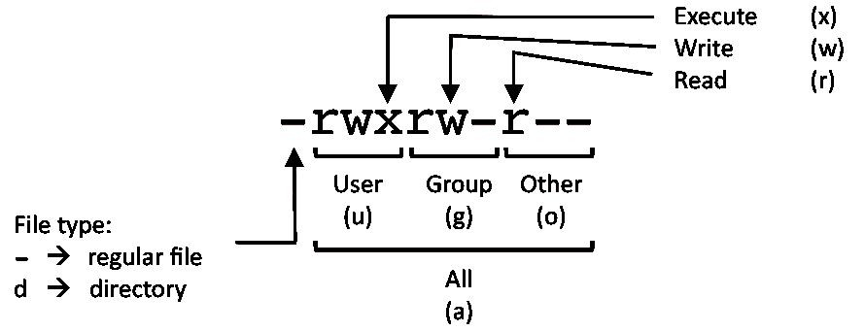

PERMISSION EXAMPLE

U G W

rwx rwx rwx chmod 777 filename # Use sparingly!

rwx rwx r-x chmod 775 filename rwx r-x r-x chmod 755 filename rw- rw- r-- chmod 664 filename rw- r-- r-- chmod 644 filename

LEGEND

U = User

G = Group

W = World

r = Read

w = write

x = execute

- = no access

8 - NETWORKING

ifconfig -a # Display all network interfaces and ip address

ifconfig eth0 # Display eth0 address and details

ethtool eth0 # Query or control network driver and hardware settings

ping host # Send ICMP echo request to host whois domain # Display whois information for domain dig domain # Display DNS information for domain dig -x IP_ADDRESS # Reverse lookup of IP_ADDRESS host domain # Display DNS ip address for domain

hostname -i # Display the network address of the host name.

hostname -I # Display all local ip addresses

wget [http://domain.com/file # Download http://domain.com/file](http://domain.com/file)

netstat -nutlp # Display listening tcp and udp ports and corresponding programs

9 - ARCHIVES (TAR FILES)

tar cf archive.tar directory # Create tar named archive.tar containing

directory.

tar xf archive.tar # Extract the contents from archive.tar.

tar czf archive.tar.gz directory # Create a gzip compressed tar file name

archive.tar.gz.

tar xzf archive.tar.gz # Extract a gzip compressed tar file.

tar cjf archive.tar.bz2 directory # Create a tar file with bzip2 compression

tar xjf archive.tar.bz2 # Extract a bzip2 compressed tar file.

10 - INSTALLING PACKAGES

yum search keyword # Search for a package by keyword.

yum install package # Install package.

yum info package # Display description and summary information about package.

rpm -i package.rpm # Install package from local file named

package.rpm

yum remove package # Remove/uninstall package.

tar zxvf sourcecode.tar.gz cd sourcecode

./configure make

make install

# Install software from source code.

11 - SEARCH

grep pattern file # Search for pattern in file

grep -r pattern directory # Search recursively for pattern in directory locate name # Find files and directories by name

find /home/john -name

'prefix*'

# Find files in /home/john that start with "prefix".

find /home -size +100M # Find files larger than 100MB in /home

12 - SSH LOGINS

ssh host # Connect to host as your local username.

ssh [user@host # Connect to host as user](mailto:user@host)

ssh -p port [user@host # Connect to host using port](mailto:user@host)

13 - FILE TRANSFERS

scp file.txt server:/tmp # Secure copy file.txt to the /tmp folder on

server

scp server:/var/www/*.html /tmp # Copy *.html files from server to the local

/tmp folder.

scp -r server:/var/www /tmp # Copy all files and directories recursively from

server to the current system's /tmp folder.

rsync -a /home /backups/ # Synchronize /home to /backups/home

rsync -avz /home

server:/backups/

# Synchronize files/directories between the local

and remote system with compression enabled

14 - DISK USAGE

df -h # Show free and used space on mounted filesystems df -i # Show free and used inodes on mounted filesystems fdisk -l # Display disks partitions sizes and types

du -ah # Display disk usage for all files and directories in human readable format

du -sh # Display total disk usage off the current directory

15 - DIRECTORY NAVIGATION

cd .. # To go up one level of the directory tree. (Change into the parent directory.)

cd # Go to the $HOME directory

cd /etc # Change to the /etc directory